Keegan Smith

Data Comm HW 7

4/13/32

|  |  |
| --- | --- |
| 1110 | **1** |
| 0110 | **0** |
| 1001 | **0** |
| 0101 | **0** |
| **0100** | **1** |

Final Checksum: 1110 1 0110 0 1001 0 0101 0 0100 1



|  |  |
| --- | --- |
| 10011001 | **0** |
| 11100010 | **0** |
| 00100100 | **0** |
| 10000100 | **0** |
| **11011011** | **0** |

10011001 11100010 00100100 10000100

Final Checksum: 10011001 0 11100010 0 00100100 0 10000100 0 11011011 0

p = probability of transmission

Max efficiency



then, N => ∞

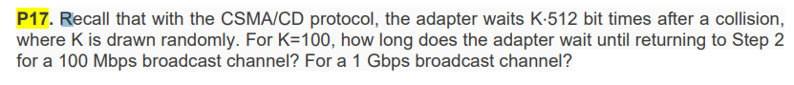 For a 100Mbps broadcast channel, the waiting time is 100 * 512 * 0.00001 = 512ms

For 1Gbps broadcast channel, the wait time is 100 * 512 * 0.0000001 = 0.000512ms

1. Source Mac: 00-00-00-00-00-00, Destination Mac: 22-22-22-22-22-22

Source IP: 111.111.111.001, Destination IP:133.333.333.333.003

1. Source Mac: 33-33-33-33-33-33, Destination Mac: 55-55-55-55-55-55

Source IP: 111.111.111.001, Destination IP: 133.333.333.003

1. Source Mac: 88-88-88-88-88-88, Destination Mac: 99-99-99-99-99-99

Source IP: 111.111.111.001, Destination IP: 133.333.333.003

EE-EE-EE-EE-EE-EE



FF-FF-FF-FF-FF-FF DD-DD-DD-DD-DD-DD



X

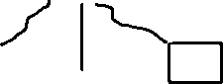

CC-CC-CC-CC-CC-CC



AA-AA-AA-AA-AA-AA



BB-BB-BB-BB-BB-BB

1. B sends a frame to E

|  |  |  |
| --- | --- | --- |
| Address | Interface | Time |
| BB-BB-BB-BB-BB-BB | 2 | T1 |
|  |  |  |

The interface for Mac address of E is not present in the switch table, so the packet is forwarded to another node.

1. E replies with a frame to B

|  |  |  |
| --- | --- | --- |
| Address | Interface | Time |
| BB-BB-BB-BB-BB-BB | 2 | T1 |
| EE-EE-EE-EE-EE-EE | 5 | T2 |

1. A sends a frame to B

|  |  |  |
| --- | --- | --- |
| Address | Interface | Time |
| BB-BB-BB-BB-BB-BB | 2 | T1 |
| EE-EE-EE-EE-EE-EE | 5 | T2 |
| AA-AA-AA-AA-AA-AA | 1 | T3 |

|  |  |  |
| --- | --- | --- |
| Address | Interface | Time |
| BB-BB-BB-BB-BB-BB | 2 | T1, T4 |
| EE-EE-EE-EE-EE-EE | 5 | T2 |
| AA-AA-AA-AA-AA-AA | 1 | T3 |



NZRI



Manchester

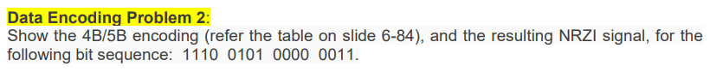

1110 => 10011

0101 => 01010

0000 => 11110

0011 => 10100

10011 01010 11110 10100

